**DAILY ONLINE ACTIVITIES SUMMARY**

|  |  |  |  |  |  |  |
| --- | --- | --- | --- | --- | --- | --- |
| **Date:** | | **11 July 2020** | **Name:** | | **KHATHEEJA SAFREENA.** | |
| **Sem & Sec** | | **4th sem, 2nd year** | **USN:** | | **4al18cs037** | |
| **Online Test Summary** | | | | | | |
| **Subject** | **-----** | | | | | |
| **Max. Marks** | **----** | | | **Score** | **---** | |
| **Certification Course Summary** | | | | | | |
| **Course** | | **GOOGLE DIGITAL MARKETING.** | | | | |
| **Certificate Provider** | | **Google digital garage.** | | **Duration** | | **40 hours** |
| **Coding Challenges** | | | | | | |
| **Problem Statement:Write a Java program for Reversal algorithm for array rotation by 3.** | | | | | | |
| **Status: Executed** | | | | | | |
| **Uploaded the report in Github** | | | | **Yes** | | |
| **If yes Repository name** | | | | [http://shafreenasharief / lockdown-coding](http://shafreenasharief / lockdown-coding" \o "http://shafreenasharief / lockdown-coding) | | |
| **Uploaded the report in slack** | | | | **Yes** | | |

Certification Course Details: (Attach the snapshot and briefly write the report for the same)

Coding Challenges Details: (Attach the snapshot and briefly write the report for the same)

**CERTIFICATION COURSE SUMMARY:**

Today I started new course **FUNDAMENTALS DIGITAL MARKETING** through **GOOGLE DIGITAL GARAGE** the course is secluded for 6hrs. After the completion of course, certificate will be provided. I completed all the module .I attempted quiz ,which gave me a clear veiw about the topics that were thought and discussed.It consists of 40 modules which also include assessments.



**ONLINE CODING:**

**Write a Java program for Reversal algorithm for array rotation by 3.**

**Given an array a[], array size n and d the number of index to be rotated task is to write a function rotate(arr[],d,n) that rotates arr[] of size n by d elements.**

**Example**

**Input:**

**n= 6**

**arr []= {1,2,3,4,5,6}**

**d=3 (specific)**

**Output: arr[]= {4,5,6,1,2,3}**

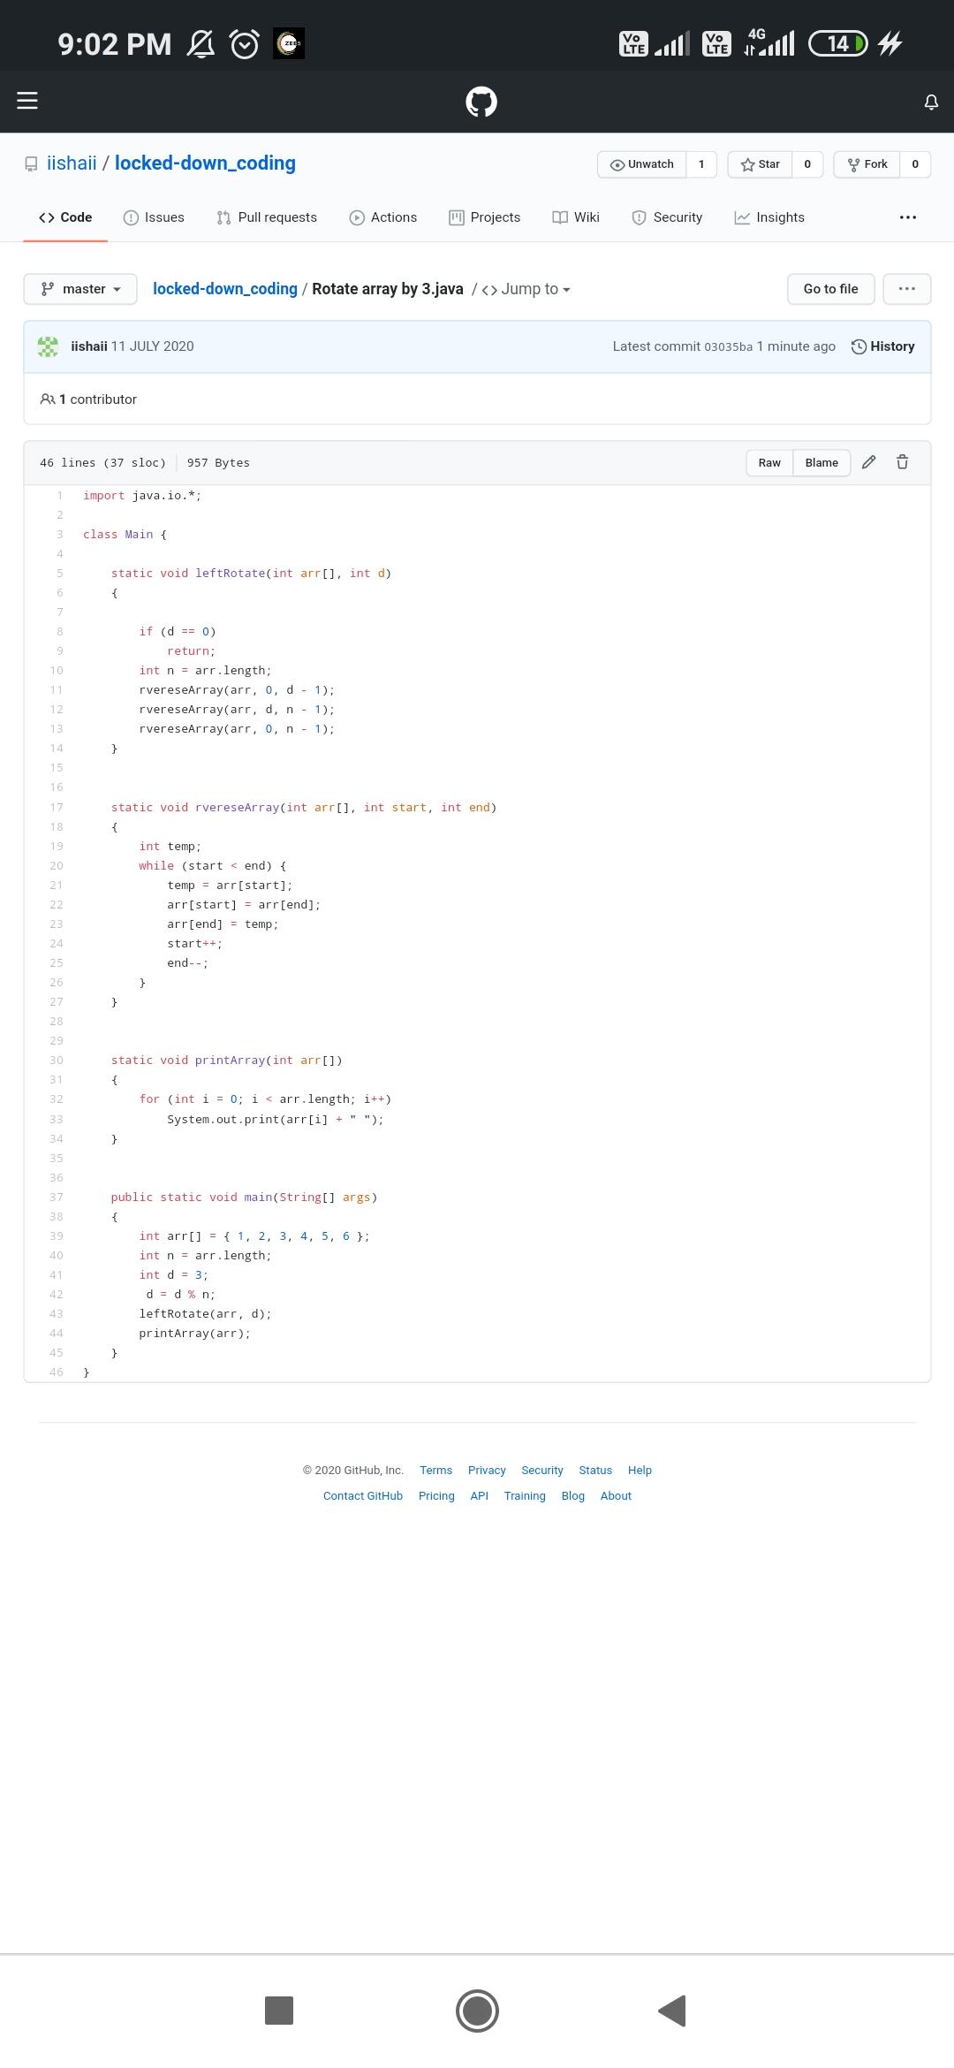

**SOLUTION** : I have uploaded the solution of the above 1 coding problems in my GitHub repository.

[http://shafreenasharief / lockdown-coding](http://shafreenasharief / lockdown-coding" \o "http://shafreenasharief / lockdown-coding)

[http://shafreenasharief / locked-down--certification-course](http://shafreenasharief / locked-down--certification-course" \o "http://shafreenasharief / locked-down--certification-course)

[http://shafreenasharief / Daily\_Report](http://shafreenasharief / Daily_Report" \o "http://shafreenasharief / Daily_Report)